

COST 32172

Web Programming



**BS/2012/208**

**g.l.s.i.karunarathna**

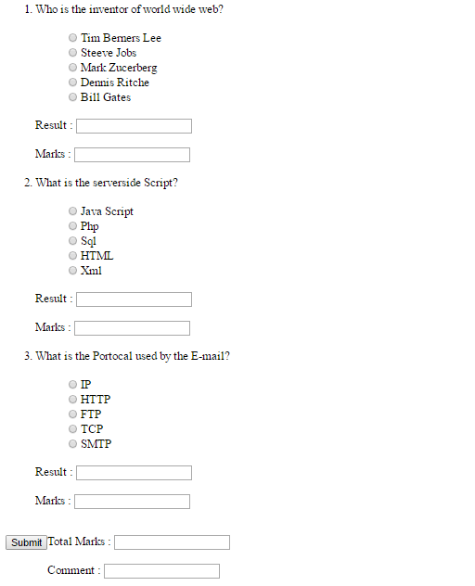

<html>

<head>

</head>

<body>

<table>

<ol>

<li>Who is the inventor of world wide web?</li>

<br/>

<ul type=none>

<li><input type="radio" name="R11" id="ri1"/>Tim Berners Lee</li>

<li><input type="radio" name="R11"id="ri2"/>Steeve Jobs</li>

<li><input type="radio" name="R11"id="ri3"/>Mark Zucerberg</li>

<li><input type="radio" name="R11"id="ri4"/>Dennis Ritche</li>

<li><input type="radio" name="R11"id="ri5"/>Bill Gates</li>

</ul>

<br/>

Result : <input type="text" id="res1" />

<br/><br/>

Marks : <input type="text" name="A1" id="A1"/>

<br/><br/>

<li>What is the serverside Script?</li>

<br/>

<ul type=none>

<li><input type="radio" name="R21" id="ri6"/>Java Script</li>

<li><input type="radio" name="R21" id="ri7"/>Php</li>

<li><input type="radio" name="R21" id="ri8"/>Sql</li>

<li><input type="radio" name="R21" id="ri9"/>HTML</li>

<li><input type="radio" name="R21" id="ri10"/>Xml</li>

</ul>

<br/>

Result : <input type="text" name="Q2" id="Q2"/>

<br/><br/>

Marks : <input type="text" name="A2" id="A2"/>

<br/><br/>

<li>What is the Portocal used by the E-mail?</li>

<br/>

<ul type=none>

<li><input type="radio" name="R31" id="ri11"/>IP</li>

<li><input type="radio" name="R31" id="ri12"/>HTTP</li>

<li><input type="radio" name="R31" id="ri13"/>FTP</li>

<li><input type="radio" name="R31" id="ri14"/>TCP</li>

<li><input type="radio" name="R31" id="ri15"/>SMTP</li>

</ul>

<br/>

Result : <input type="text" name="Q3" id="Q3" />

<br/><br/>

Marks : <input type="text" name="A3" id="A3"/>

<br/><br/>

</ol>

<tr>

<input type="Submit" onclick="myFunction()">Total Marks : <input type="text" name="Tot" id="Tot"/> <br/>

<br/><div align="left"> &nbsp; &nbsp;&nbsp; &nbsp; &nbsp; &nbsp;

&nbsp; &nbsp;

Comment : <input type="text" name="Comm" id="Comm"/></div>

</tr>

</table>

<p id="demo"></p>

<script type="text/javaScript">

function myFunction() {

var i=0;

var x=10;

var z=0;

if(document.getElementById("ri1").checked){

document.getElementById("res1").value = "correct";

i+=10;

document.getElementById("A1").value = x;

}else{

document.getElementById("res1").value = "Incorrect";

document.getElementById("A1").value = z;

}

if(document.getElementById("ri7").checked){

document.getElementById("Q2").value = "correct";

i+=10;

document.getElementById("A2").value = x;

}else{

document.getElementById("Q2").value = "Incorrect";

document.getElementById("A2").value = z;

}

if(document.getElementById("ri15").checked){

document.getElementById("Q3").value = "correct";

i+=10;

document.getElementById("A3").value = x;

}else{

document.getElementById("Q3").value = "Incorrect";

document.getElementById("A3").value = z;

}

document.getElementById("Tot").value = i;

var txt;

if(i>=30){

txt="Excellent";

}else if(i>=20){

txt="Very Good";

}else if(i>=10){

txt="Good";

}else if(i>=0){

txt="Word Hard";

}

document.getElementById("Comm").value = txt;

}

</script>

</body>

</html>

02 )

<html>

<head>

</head>

<body>

<script type="text/javaScript">

var error;

function validateForm(){

if(error==1){

alert("Form can't Submit");

return false;

}else{

return true;

alert("<img src='download (4).jpg'/> &nbsp;Form Sucessfully Submit");

}

}

function checkName(){

var name=document.getElementById("fname").value;

var element=document.getElementById("fnamelable");

if(name.length<10 && name===""){

error=1;

element.innerHTML="*first name should be at leat 5 characters and that can't be Empty";

element.style.color="red";

}else{

error=0;

element.innerHTML="<img src='download (4).jpg'/> &nbsp;Done valid First Name";

element.style.color="green";

}

}

function checkadd(){

var add=document.getElementById("address").value;

var addelement=document.getElementById("addresslable");

if(add===""){

error=1;

addelement.innerHTML="*That can't be empty";

addelement.style.color="red";

}else{

error=0;

addelement.innerHTML="<img src='download (4).jpg'/> &nbsp;Done valid Address";

addelement.style.color="green";

}

}

function checkzip(){

var zip=document.getElementById("zipcode").value;

var zipelement=document.getElementById("ziplable");

if(zip==="" && zip.length<10){

error=1;

zipelement.innerHTML="*That can't be empty";

zipelement.style.color="red";

}else{

error=0;

zipelement.innerHTML="<img src='download (4).jpg'/> &nbsp;Done valid Address";

zipelement.style.color="green";

}

}

function checkstat(){

var stat=document.Q2.status.value;

var staelement=document.getElementById("statuslable");

if(stat==="Please Select"){

error=1;

staelement.innerHTML="*Status Should be select ";

staelement.style.color="red";

}else{

error=0;

staelement.innerHTML="<img src='download (4).jpg'/> &nbsp;Done valid Selection on Status";

staelement.style.color="green";

}

}

function checkuser(){

var user=document.getElementById("user").value;

var element=document.getElementById("userlable");

if(user===""){

error=1;

element.innerHTML="*That can't be empty";

element.style.color="red";

}else{

error=0;

if(user.length>6 && user.length<8){

element.innerHTML="<img src='download (4).jpg'/> &nbsp;Done valid User Name";

element.style.color="green";

}else{

element.innerHTML="*Length should be in between 6-8";

element.style.color="red";

}

}

}

function checkemail(){

var email=document.getElementById("email").value;

var element=document.getElementById("emaillable");

var atpos=email.indexOf("@");

var dotpos=email.lastIndexOf(".");

if(email==="" && atpos<1|| dotpos<atpos+2||dotpos+2>=email.length){

error=1;

element.innerHTML="*That can't be empty OR Wrong Email format";

element.style.color="red";

}else{

error=0;

element.innerHTML="<img src='download (4).jpg'/> &nbsp; Done valid Address";

element.style.color="green";

}

}

</script>

<form onsubmit="return validateForm()" id="Q2" name="Q2" method="post" action="submit_form.asp">

<table>

<tr>

<td>

First Name : &nbsp;&nbsp;&nbsp;&nbsp;&nbsp;&nbsp;&nbsp;&nbsp;

</td>

<td>

<input type="text" id="fname" name="fname" onblur="checkName()"/>

</td>

<td>

<label id="fnamelable"></label>

</td>

</tr>

<tr>

<td>

Address: &nbsp;&nbsp;&nbsp;&nbsp;&nbsp;&nbsp;&nbsp;&nbsp;

</td>

<td>

<textarea rows="4" cols="50" id="address" name="address" onblur="checkadd()"></textarea>

</td>

<td>

<label id="addresslable"></label>

</td>

</tr>

<tr>

<td>

Zip Code: &nbsp;&nbsp;&nbsp; &nbsp;&nbsp;&nbsp;&nbsp;&nbsp;&nbsp;&nbsp;&nbsp;&nbsp;&nbsp;&nbsp;&nbsp;&nbsp;&nbsp;

</td>

<td>

<input type="text" name="zipcode" id="zipcode" onblur="checkzip()"/>

</td>

<td>

<label id="ziplable"></label>

</td>

</tr>

<tr>

<td>

Status: &nbsp;&nbsp;&nbsp; &nbsp;&nbsp;&nbsp;&nbsp;&nbsp;&nbsp;&nbsp;&nbsp;&nbsp;&nbsp;&nbsp;&nbsp;&nbsp;&nbsp;

</td>

<td>

<select id="status" name="status" onblur="checkstat()">

<option value="Please Select">Please Select</option>

<option value="Mr">Mr</option>

<option value="Miss">Miss</option>

<option value="Mrs">Mrs</option>

<option value="Rev">Rev</option>

</select>

</td>

<td>

<label id="statuslable"></label>

</td>

</tr>

<tr>

<td>

Username(6-8 characters): &nbsp;&nbsp;&nbsp; &nbsp;&nbsp;&nbsp;&nbsp;&nbsp;&nbsp;&nbsp;&nbsp;&nbsp;&nbsp;&nbsp;&nbsp;&nbsp;&nbsp;

</td>

<td>

<input type="text" name="user" id="user" onblur="checkuser()"/>

</td>

<td>

<label id="userlable"></label>

</td>

</tr>

<tr>

<td>

Email: &nbsp;&nbsp;&nbsp; &nbsp;&nbsp;&nbsp;&nbsp;&nbsp;&nbsp;&nbsp;&nbsp;&nbsp;&nbsp;&nbsp;&nbsp;&nbsp;&nbsp;

</td>

<td>

<input type="text" name="email" id="email" onblur="checkemail()"/>

</td>

<td>

<label id="emaillable"></label>

</td>

</tr>

<tr>

<td>

</td>

<td>

<input type="Submit" name="submit" align="center">

</td>

</tr>

</table>

</form>

</body>

</html>

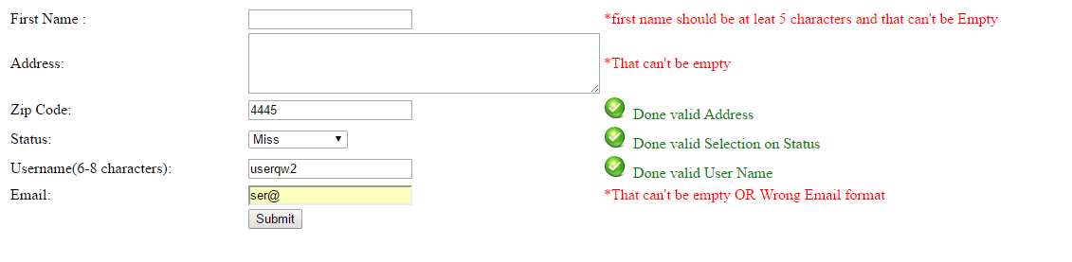

03 )

<html>

<head>

</head>

<body>

<script type="text/javaScript">

function validateForm(){

if(error==1){

alert("Form can't Submit");

return false;

}else{

purch=document.getElementById("purches").value;

dis=document.getElementById("discount").value;

pct =(1+dis/100);

pay=(purch*pct);

document.getElementById("payable").value = pay;

return true;

alert("<img src='download (4).jpg'/> &nbsp;Form Sucessfully Submit");

}

}

function checkpur(){

var purch=document.getElementById("purches").value;

var element=document.getElementById("purcheslbl");

if(purch===""){

error=1;

element.innerHTML=" &nbsp; Total Purches cannot be Empty";

element.style.color="red";

}else{

error=0;

element.innerHTML="<img src='download (4).jpg'/> &nbsp;Done Correct Purches amount";

element.style.color="green";

}

}

function checkDis(){

var dis=document.getElementById("discount").value;

var elem=document.getElementById("dicountlbl");

if(dis===""){

error=1;

elem.innerHTML="Discount Cannot be empty";

elem.style.color="red";

}else{

if(dis<=25){

elem.innerHTML="<img src='download (4).jpg'/> &nbsp; Done Correct discount Value";

elem.style.color="green";

}else{

error=0;

elem.innerHTML="Error Discount should be below 25%";

elem.style.color="red";

}

}

}

</script>

<table>

<tr>

<td>

Total Purches Rs: &nbsp;&nbsp;&nbsp;&nbsp;&nbsp;&nbsp;&nbsp;&nbsp;

</td>

<td>

<input type="text" name="purches" id="purches" onblur="checkpur()"/>

</td>

<td>

<label id="purcheslbl"></label>

</td>

</tr>

<tr>

<td>

Discount presentage: &nbsp;&nbsp;&nbsp; &nbsp;&nbsp;&nbsp;&nbsp;&nbsp;&nbsp;&nbsp;&nbsp;&nbsp;&nbsp;&nbsp;&nbsp;&nbsp;&nbsp;

</td>

<td>

<input type="text" name="Discount" id="discount" onblur="checkDis()"/>&nbsp;&nbsp; %

</td>

<td>

<label id="dicountlbl"></label>

</td>

</tr>

<tr>

<td>

</td>

<td>

<input type="Submit" name="Calculate" value="Calculate" align="center" onclick="validateForm()">

</td>

</tr>

<tr>

<td>

Total payable is Rs: &nbsp;&nbsp;&nbsp; &nbsp;&nbsp;&nbsp;&nbsp;&nbsp;&nbsp;&nbsp;&nbsp;&nbsp;&nbsp;&nbsp;&nbsp;&nbsp;&nbsp;

</td>

<td>

<input type="text" name="payable" id="payable"/>

</td>

</tr>

</table>

</body>

</html>

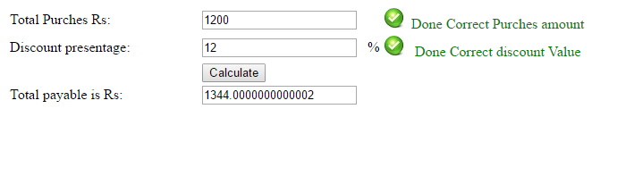 04 )

<html>

<head>

</head>

<body>

<script type="text/javaScript">

function check(){

if(document.getElementById('ri1').checked){

var element=document.getElementById("lbl");

element.innerHTML="<br/><br/><br/><br/><br/><br/><br/>Test Cell <br/><br/><br/><br/><br/><br/>";

element.style.background="Black";

element.style.color="white";}

if(document.getElementById('ri2').checked){

var element=document.getElementById("lbl");

element.innerHTML="<br/><br/><br/><br/><br/><br/><br/>Test Cell <br/><br/><br/><br/><br/><br/>";

element.style.background="green";

element.style.color="white";}

if(document.getElementById('ri3').checked){

var element=document.getElementById("lbl");

element.innerHTML="<br/><br/><br/><br/><br/><br/><br/>Test Cell <br/><br/><br/><br/><br/><br/>";

element.style.background="red";}

if(document.getElementById('ri4').checked){

var element=document.getElementById("lbl");

element.innerHTML="<br/><br/><br/><br/><br/><br/><br/>Test Cell <br/><br/><br/><br/><br/><br/>";

element.style.background="yellow";}

if(document.getElementById('ri5').checked){

var element=document.getElementById("lbl");

element.innerHTML="<br/><br/><br/><br/><br/><br/><br/>Test Cell <br/><br/><br/><br/><br/><br/>";

element.style.background="blue";

}

if(document.getElementById('ri6').checked){

var element=document.getElementById("lbl");

element.innerHTML="<br/><br/><br/><br/><br/><br/><br/>Test Cell <br/><br/><br/><br/><br/><br/>";

element.style.background="pink";

}}

function reset(){

var element=document.getElementById("lbl");

element.innerHTML="<br/><br/><br/><br/><br/><br/><br/> Test Cell <br/><br/><br/><br/><br/><br/>";

element.style.background="white";

element.style.color="Black";

}

</script>

<table>

<tr>

<td>

<ul type=none>

<li><input type="radio" name="R1" id="ri1" onchange="check()" />Black</li>

<br/>

<li><input type="radio" name="R1"id="ri2"onchange="check()"/>Green</li>

<br/>

<li><input type="radio" name="R1"id="ri3"onchange="check()"/>Red</li>

<br/>

<li><input type="radio" name="R1"id="ri4"onchange="check()"/>Yellow</li>

<br/>

<li><input type="radio" name="R1"id="ri5"onchange="check()"/>Blue</li>

<br/>

<li><input type="radio" name="R1"id="ri6"onchange="check()"/>Pink</li>

<br/>

<li><input type="Reset" name="set"id="set" onclick="reset()"/></li>

</ul>

</td>

<td>

</td>

<td>

<div id="lbl">

</div>

</td>

</tr>

</table>

</body>

</html>

